Neil Shorney, The Sales Accelerator
Chief Possibility Officer at Navanter

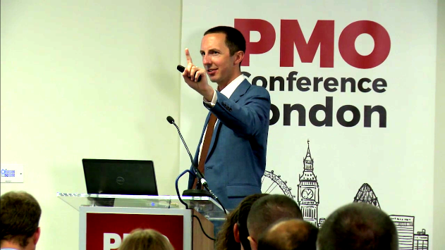

Neil Shorney is an award-winning international sales trainer, engaging speaker, and renowned sales expert who has brought his cutting-edge sales approach to professionals from five continents.

Neil found early sales success generating new business through cold-calling at a tech start-up. His career really took off working for Informa plc – the London-based global information powerhouse. As a key sales leader in their project management division, Neil was renowned for his skill in taking fresh graduates and developing them into senior salespeople and sales leaders. He won three awards, for developing sales talent, creating sales career paths, and for breaking revenue records.

Neil founded Navanter in 2011 to show the world that there’s a better way to sell, through his unique fusion of cutting-edge sales techniques with the skills of top project professionals.

